Experiment 1 – To Simulate, operation of Multiple Access Techniques for CDMA  
  
Code -  
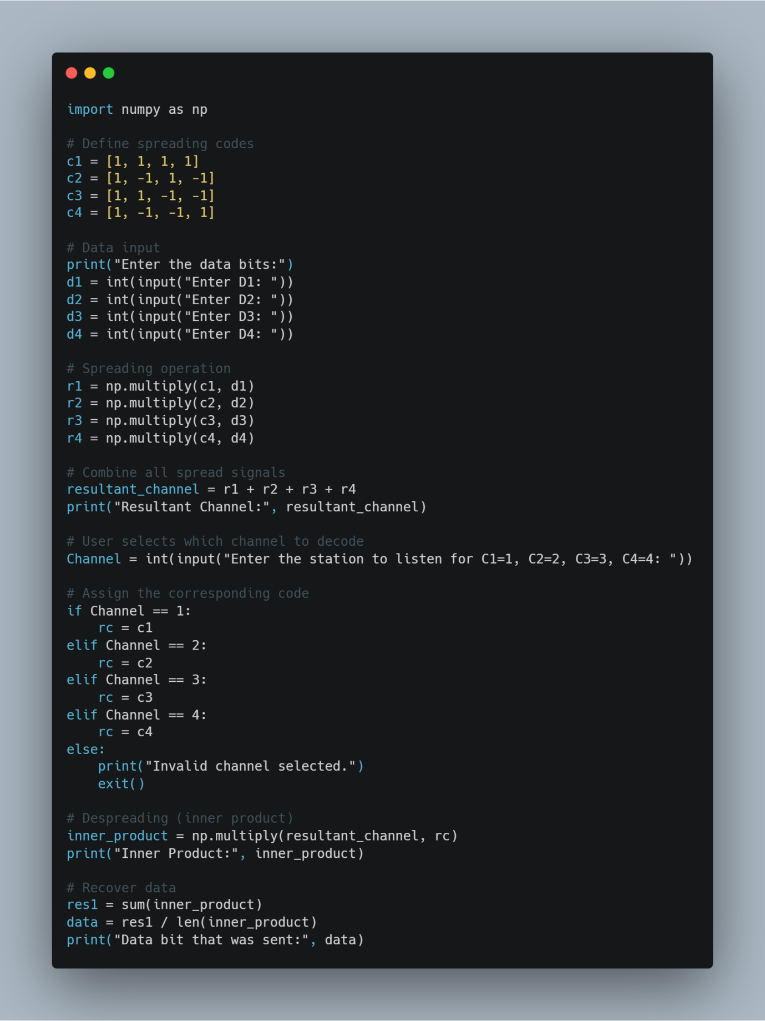

Output -  
